Task 2 - Firewall Configuration
1.Install UFW on your Linux system (if not already installed) and enable it, then verify its status using the appropriate commands.
Step 1:- Install UFW by running:
- #sudo apt update
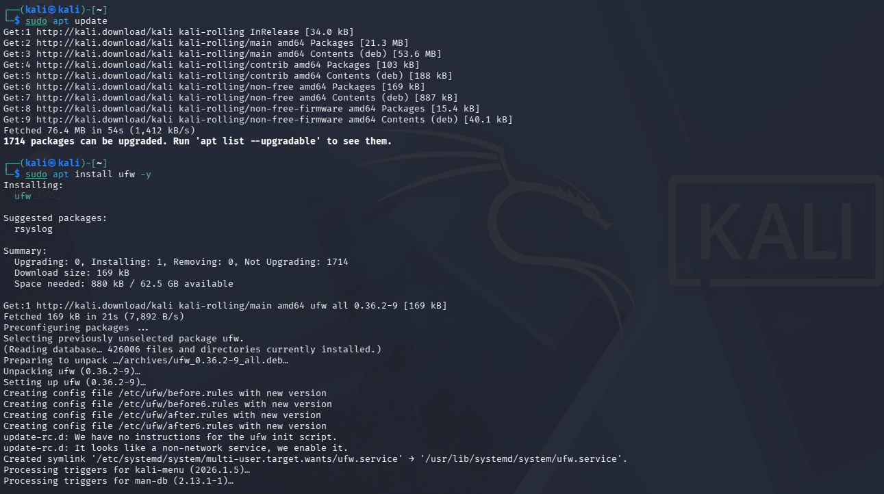
- #sudo apt install ufw -y

Step 2: Enable UFW and Verify Its Status
After installing UFW, I enabled the firewall using the following command:
#sudo ufw enable
I then verified that the firewall was running by checking its status.
#sudo ufw status
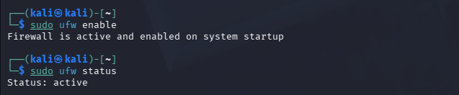
2.Allow incoming SSH (port 22) and HTTP (port 80) traffic using UFW. Then list all current firewall rules.
Step 1: Allow SSH and HTTP Traffic
To allow remote administration and web traffic, I added firewall rules for SSH (Port 22) and HTTP (Port 80).
Commands:
#sudo ufw allow 22/tcp
#sudo ufw allow 80/tcp
After adding the rules, I displayed all configured firewall rules using: #sudo ufw status numbered
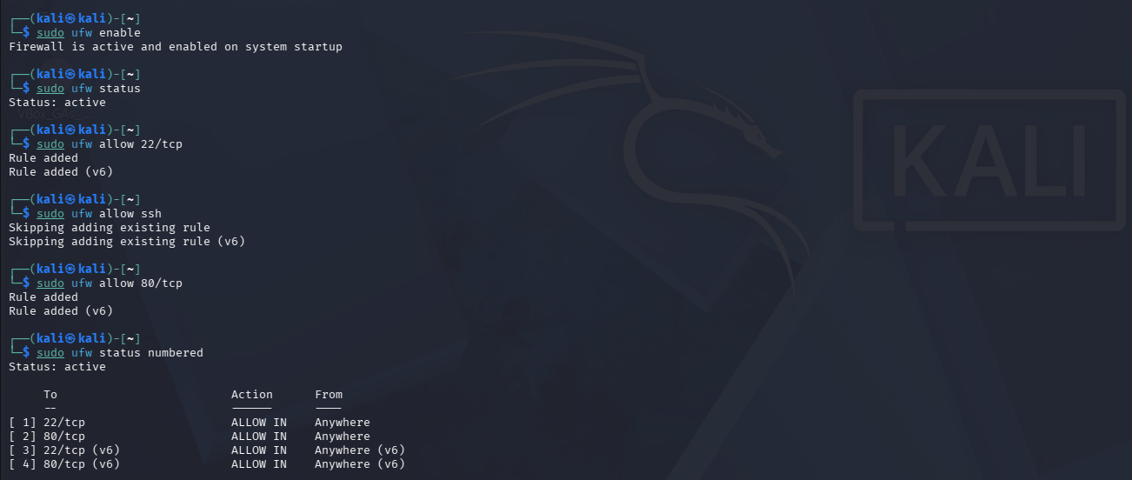
Step 1: Block Telnet (Port 23)
To improve system security, I blocked incoming Telnet traffic by creating a firewall rule that denies access to TCP port 23.
Command: #sudo ufw deny 23/tcp
After adding the rule, I verified the firewall configuration using: #sudo ufw status numbered
The output confirmed that incoming Telnet traffic on port 23 was denied.
